

CAPSTONE PROJECT REPORT
Report 4 – Software Design Specification

– Hanoi, Jul 2026 –

Table of Contents
I. Record of Changes 3
II. Software Design Document 4
1. High Level Design 4
1.1 Software Architecture 4
1.2 Package Diagram 4
1.3 Database Design 5
2. Detailed Design 7
2.1 <Feature/Function Name1> 7
2.2 <Feature/Function Name2> 8
3. Class Specifications 8
3.1 package_name1 8
4. Other Design Specifications 9

I. Record of Changes
Date | A*  M, D | In charge | Change Description
02/07/2026 | A | HungPV | Added Section II.1.1 Software Architecture (high-level architecture diagram and component descriptions)
*A - Added M - Modified D - Deleted

II. Software Design Document

1. High-Level Design

1.1 Software Architecture
The Smart Warehouse Execution System (SWES) is designed as a layered, event-driven modular monolith. The system consists of a React single-page application (wes-client), a NestJS backend (wes) that owns all business logic, and a customized openTCS kernel (FMS) that executes physical routing and AGV control. The backend takes over the default openTCS dispatching: every transport order is pushed to the kernel with an already-assigned vehicle (intendedVehicle). Figure II-1 shows the overall architecture, the external systems, and the communication messages between the components.
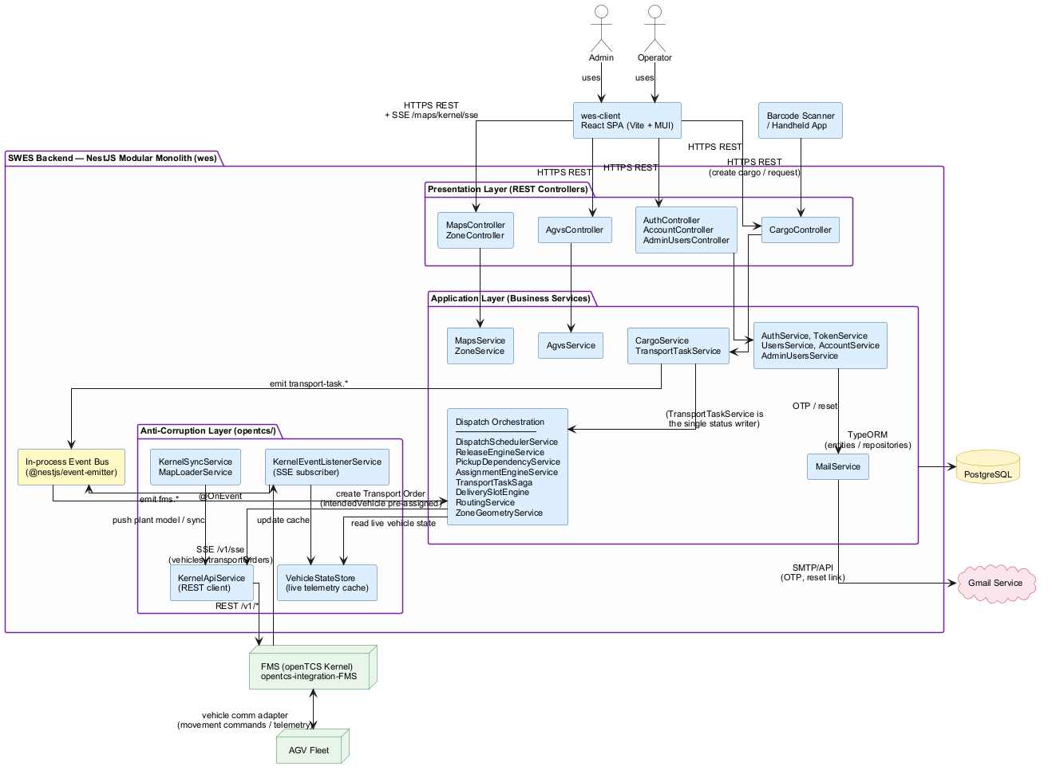
Figure II-1. SWES high-level software architecture
The responsibilities of each component in the diagram are described below:
No | Component | Description
01 | Admin / Operator | Human actors. The Admin configures the system (fleet, map/topology, users, dispatch policies) and monitors operations; the Operator creates and tracks transport requests. Both interact with the system through the wes-client web application.
02 | Barcode Scanner / Handheld App | On-site edge client. It optically decodes floor QR codes and package barcodes, then calls the SWES REST API to create a Cargo record and initiate the lifecycle of a Transport Request.
03 | wes-client (React SPA) | Single-page web application built with React, Vite and MUI. It renders data served by the backend over HTTPS REST and subscribes to the backend SSE endpoint (/maps/kernel/sse) for live AGV tracking on the warehouse map. It contains no business logic.
04 | Presentation Layer (REST Controllers) | NestJS controllers exposing the system API: AuthController/AccountController/AdminUsersController (authentication and user management), AgvsController (fleet registry), MapsController/ZoneController (map, topology and the SSE stream), CargoController (cargo and transport requests, also consumed by the barcode scanner). Controllers validate DTOs, enforce JWT/role guards and delegate to services.
05 | Application Layer (Business Services) | All business use cases. CargoService manages cargo records; TransportTaskService is the single write choke point for transport-task status (validate via state machine, persist, emit event). The Dispatch Orchestration group implements the core value of SWES: ReleaseEngineService with PickupDependencyService gates CREATED tasks (row-dependency anti-congestion rule, BLOCKED state), AssignmentEngineService selects the nearest eligible AGV (Dijkstra over the plant-model road graph via RoutingService), TransportTaskSaga advances the three-leg order flow (pick-up, approach, drop-off), DeliverySlotEngine late-binds the concrete drop-off slot, and DispatchSchedulerService debounces and triggers release/assignment cycles. Supporting services: AgvsService, MapsService/ZoneService, AuthService/TokenService/UsersService/AccountService/AdminUsersService, MailService.
06 | In-process Event Bus (@nestjs/event-emitter) | Decouples producers and consumers inside the monolith. TransportTaskService emits transport-task.* events; the openTCS listener emits fms.* events; engines react via @OnEvent handlers. No external message broker is used.
07 | Anti-Corruption Layer (opentcs/) | The only place that talks to openTCS. KernelApiService wraps the kernel REST API (transport orders, plant model, vehicles); KernelEventListenerService subscribes to the kernel SSE stream and translates telemetry frames into fms.* domain events; VehicleStateStore caches live vehicle telemetry in memory; KernelSyncService and MapLoaderService push/synchronize the plant model at startup. openTCS types never leak into business modules.
08 | PostgreSQL | Relational database accessed through TypeORM entities/repositories. Stores AGVs, cargos, transport requests, maps, zones, points/paths, users and the append-only event log.
09 | FMS (openTCS Kernel) | External fleet-management middleware (customized openTCS, project opentcs-integration-FMS). It receives transport orders whose vehicle has already been chosen by SWES, performs pathfinding and physical vehicle control, and continuously publishes vehicle and transport-order telemetry to SWES over SSE (/v1/sse).
10 | AGV Fleet | The physical automated guided vehicles. They communicate only with the openTCS kernel through its vehicle communication adapters (movement commands and telemetry).
11 | Gmail Service | Third-party email delivery service used by MailService to send authentication emails: OTP codes and password-reset links.

1.2 Package Diagram
[Provide the package diagram for each sub-system. The content of this section including the overall package diagram, the explanation, package and class naming conventions in each package. Please see the sample & description table format below]
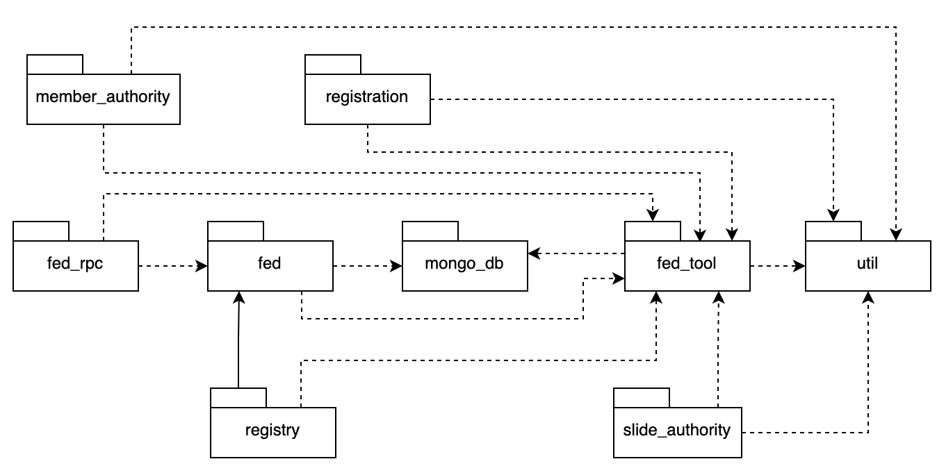
Package descriptions
No | Package | Description
01 | Member_authority | <Description of the package>
02 | registration | <Description of the package>
03 | …

1.3 Database Design
[Provide the files description, database table relationship & table descriptions like example below]
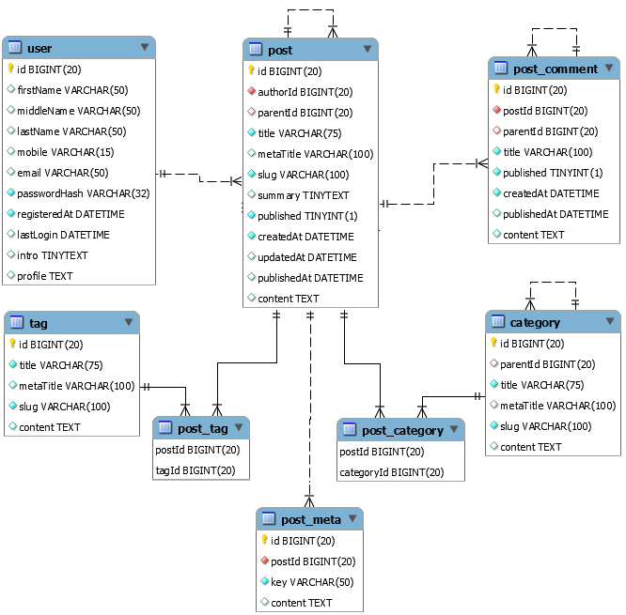

1.3.1 table_name1
[Provide brief description of the table here]
[Provide the detailed table fields description using below table format
* PK~Primary Key; FK~Foreign Key; UN~Unique; NN ~ not null
No | Field | PK | FK | UN | NN | Description
01 | <field_name1> |  |  |  |  | <Description of the field_name1>
02 | <field_name2> |  |  |  |  | …
..

1.3.2 table_name2
…

2. Detailed Design

2.1 <Feature/Function Name1>
[Provide the detailed design for the feature <Feature Name1>. It includes Class Diagram and Sequence Diagram(s); For the features/functions with the same structure of class & sequence diagrams, you need to provide the diagrams once for one feature/function and refer to those diagrams from other features/functions]

2.1.1 Class Diagram
[This part presents the class diagram for the relevant feature]
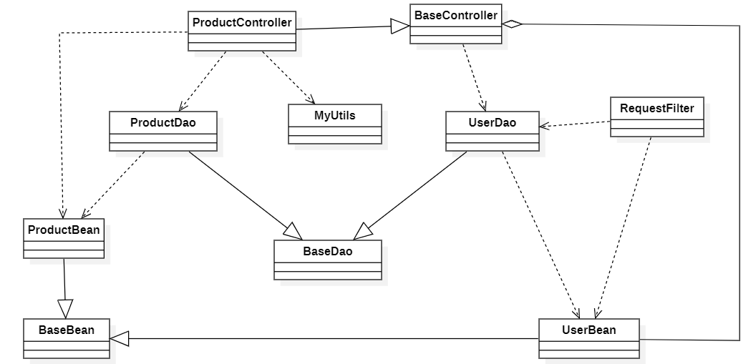

2.1.2 <Sequence Diagram Name1>
[Provide the sequence diagram(s) for the feature, see the sample below]
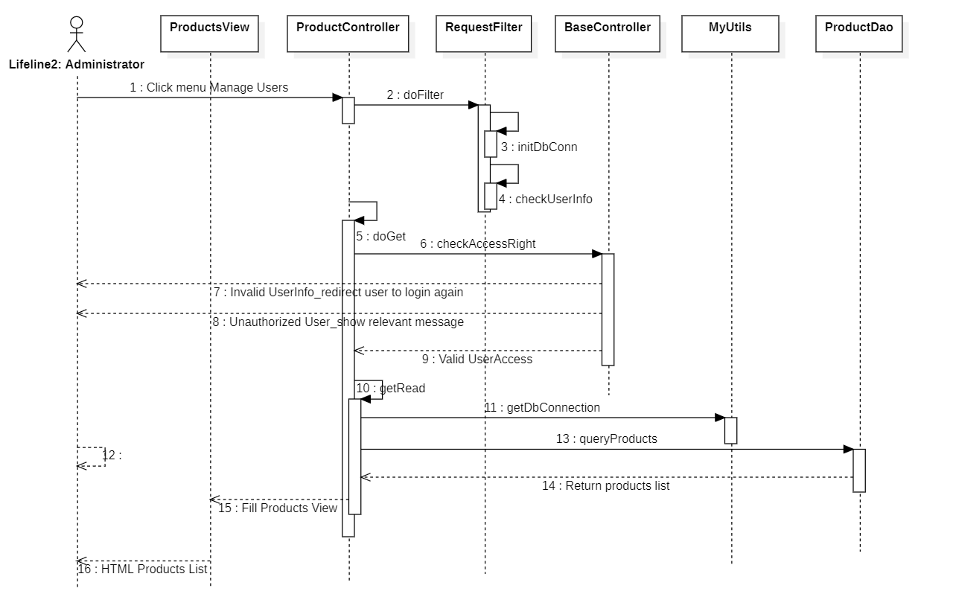

2.1.3 <Sequence Diagram Name2>

2.1.4 …

2.2 <Feature/Function Name2>
…

3. Class Specifications

3.1 package_name1
This section provides the detailed specifications for the classes in the package package_name1

3.1.1 ClassName1
[Provide brief description of the class here]
[Provide the class attributes and operations using below table format
No | Name | Description
Attributes
01 | <attributeName1> | Visibility: <attribute’s visibility: private, protected, default…>  Type: <data type of the attribute: int, String...>  Purpose: <description or purpose of the attribute>
02 | <attributeName2> | …
..
Methods/Operations
01 | <methodName1> | Visibility: <operation’s visibility: private, protected, default…>  Return: <void or return type of the operation: int, String,..>  Purpose: <description or purpose of the method>  Parameters: <<list out all the method parameters and provide details (name, data type, purpose/description) of each method parameter here  - paramName1:type1, purpose/description1  - paramName2:type2, purpose/description1  >>
02 | <methodName2> | …
..
]

3.1.1 ClassName2
…

4. Other Design Specifications
[Provide any other design specifications here: data design, system integrations, algorithms, etc.]

…

